|  |
| --- |
| crabapples  (apples) |
| *Malus* species |
| Plant Symbol = MALUS |

Contributed by: USDA NRCS Plant Materials Program

Uses

Crabapples are used primarily in landscape plantings, in shelterbelts, and for wildlife benefits. The fruit is eaten by songbirds and upland game, and can be used for making jellies and spiced apples.

Status

Please consult the PLANTS Web site and your State Department of Natural Resources for this plant’s current status (e.g. threatened or endangered species, state noxious status, and wetland indicator values).

Description

Crabapples (*Malus* species) include about 25 species of deciduous or rarely half-evergreen trees or shrubs native to the temperate regions of North America, Europe, and Asia. They vary from a large shrub-like plant, 6 to 8 feet, to a medium tree, 15 to 35 feet. The branches are slender and upright. Flowers are showy and vary in color from white to pink to deep red. Blooms appear from mid April to early June depending on location. The apples produced are either red or yellow and vary in size from 1/4 inch diameter up to 3/4 inch.

*Malus mandshurica* (Maxim.) Kom., Siberian crabapple, is a tall, spreading species, 25 to 35 feet in height, best suited to large, open areas. Profuse, fragrant flowers appear in May. The fruit, which can range in color from red to yellow, ripens from August to November. This species is often used in beach gardens which offer some protection from salt and wind.

*Malus coronaria* (L.) P. Mill., sweet crab, grows upright to as a shrub 15 to 25 feet tall, with pink flowers which appear in mid-March. The large fruit is used as a main wildlife food.

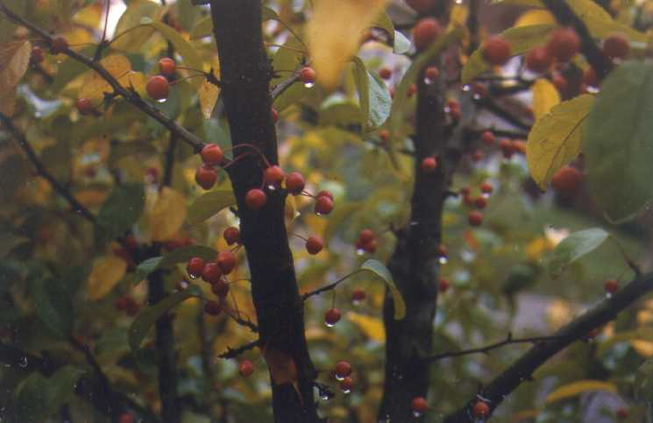

USDA NRCS National Plant Materials Center

Beltsville, MD

*Malus floribunda* Sieb. ex Van Houtte, Japanese flowering crab, reaches a mature height of 20 to 25 feet and blooms heavily in May. The blooms are deep pink, fading to white. The red and yellow fruit stays on the branches into the winter, providing a food source for wildlife.

*Malus sargeniti* Rehd., Sargent crab, is a bushy, densely branched shrub, usually twice as wide as it is tall. Its white flowers bloom profusely in mid May and are followed by deep red fruit, which remains on the branches until December. In addition to the general uses listed above, Sargent crab can be effectively used as a pruned hedge.

*Malus sieboldii* (Regel) Rehd., toringa crab, ranges in size from a shrub to a small tree. Its flowers are white and single, and its reddish‑yellow fruit hangs in clusters from the branches.

Adaptation

Crabapples can be grown on medium to heavy soils that are somewhat poorly to well drained. The pH should be 5.5 or higher. Full sun is preferred for best performance, but they will tolerate light shade.

Crabapples is distributed throughout the majority of the United States. For a current distribution map, please consult the Plant Profile page for this species on the PLANTS Website.

Establishment

Crabapples, like other trees and shrubs should not be planted into living sod. The site should be prepared a year ahead so that early spring plantings can be made into weed free locations that are two feet larger in radius than the seedlings. Nursery seedlings of the species discussed above should be planted as early in the spring as possible. Grafted varieties are usually purchased as container plants. When planted, the graft must be above ground. Do not fertilize during the establishment year. Prune off all side branches that are not desired for permanent limbs, and provide protection from rabbits and deer in high population areas.

In hedgerows, space the plants 10 feet apart for ‘Roselow’ and 15-20 feet apart for ‘Midwest’. Plant at least 10 feet away from buildings. Mulching with hay, wood shavings, grass clippings, etc. will help maintain moisture and control weeds.

Management

Weeds must be controlled for the first 2 years if plants are to survive. The application of fertilizer is notrecommended at thetime of establishment. The size and shape of the tree can be managed by pruning. Prune all branches that form sharp angles with the trunk, and remove all side branches except those desired for permanent limbs. Once crabapples become well established, little care is required.

Pests and Potential Problems

Weeds and grass, if left to grow around young plants can stifle their growth. Rabbits may damage or kill young plants. If the rabbit population is high, some protection is recommended. Diseases include fireblight, apple scab, frogeye leaf spot, and black rot. Insects include fall webworm cankerworms, and apple maggot.

Cultivars, Improved, and Selected Materials (and area of origin)

There are many ornamental cultivars of crabapple available from commercial nurseries and garden centers. Most are horticultural selections intended for urban and suburban landscapes, and many of these are grafted onto select rootstocks. The variety should be selected based on the intended use. If the use is primarily for wildlife food, seedlings of the species can be purchased at a fraction of the cost of grafted varieties which are recommended for ornamental plantings. The seed propagated conservation selections exhibit some variability. Some of the cultivars selected for conservation use include:

‘Midwest’ Siberian crab (Asia) is 25-35 feet tall, and usually spreads at least that wide. It needs considerable space for full development. ‘Midwest’ has white flowers with a pink cast, and is hardy everywhere in the Northeast.

‘Roselow’ sargent crab (Japan) is a bushy, densely branched shrub that is often twice as wide as the 8 foot height. White flowers produce deep red fruit. ‘Roselow’ can be pruned as a hedge. Avoid planting this cultivar in wetter soils. It is not hardy in the northern counties of NY, VT, NH, and ME.

Common toringa crab is variable in size but generally is a small tree. It has white flowers and reddish yellow fruit that is borne in clusters. It is not hardy in NY, VT, NH, ME, and northwestern MA.

Prepared By & Species Coordinator:

USDA NRCS Northeast Plant Materials Program

Edited: 05Feb2002 JLK; 060802 jsp

For more information about this and other plants, please contact your local NRCS field office or Conservation District, and visit the PLANTS Web site<<http://plants.usda.gov>> or the Plant Materials Program Web site <<http://Plant-Materials.nrcs.usda.gov>>

*The U.S. Department of Agriculture (USDA) prohibits discrimination in all its programs and activities on the basis of race, color, national origin, sex, religion, age, disability, political beliefs, sexual orientation, and marital or family status. (Not all prohibited bases apply to all programs.) Persons with disabilities who require alternative means for communication of program information (Braille, large print, audiotape, etc.) should contact USDA's* [*TARGET Center*](http://www.usda.gov/oo/target.htm) *at 202-720-2600 (voice and TDD).*

*To file a complaint of discrimination write USDA, Director, Office of Civil Rights, Room 326-W, Whitten Building, 14th and Independence Avenue, SW, Washington, DC 20250-9410 or call 202-720-5964 (voice or TDD). USDA is an equal opportunity provider and employer.*

*Read about* [*Civil Rights at the Natural Resources Convervation Service*](http://www.nrcs.usda.gov/about/civilrights/)*.*